Summary of the reading challenge
In January 2015 our Erasmus+ team announced a competition Called „Reading Challenge” aiming to get involved all the students of our school reading as many books as possible in a year’s time. Of course we offered attracive rewards for the winners both individuals and classses.
Beforehand we had serious debates on the form of the challenge, stating the rules and motivation. Finally we agreed not to put limitations, let students chose freely from the pieces of literature, any kind, any language… The challenge in reality was in the number of read novels. Also they were informed about the rules, among them about the final, when the best ones would have to compete for the victory testing their memories and knowledge.
We organised a campaigne involving all the classes with an attractive placard, the blue giant bookworm – just swallowing books. All classes had a piece of this on their notice boards not to forget about it.
At the beginning it was not a great success – only some of the crasiest ones started to register on the given site. It was totally different from the results of our previous questionnaire about reading habits, that stated that nearly 70 % of our students read on a daily basis. At halftime there were only some hundred books registered by some students.
Then the second wawe came: we wanted to involve the new classes (after summer holidays, new school year started) and at the same time we wanted to wake up the enthusiasm of the old ones. There were a thousand leaflets prepared from our blue giant bookworm, given in hands at the time of a morning assembly. All the students were personally touched!
Additionally our teachers were involved: They could support their favourite classes with registering their books read. Csötönyi Nóra, one of the math teachers must be mentioned with her impressive 25 books! Her example showed how motivating it was for her class! By the end of the challenge they registered more than 300 boks.
Of course our beloved headmaster joined us, as well.
This second campaign was very successful: an amasing number of 1028 books were registered on the list.
We made it!
And that’s not the end!
The best ones appeared at the final, presented their favourite authors and novels, and filled in a test, prepared for them individually: from 10 of the books they named to be read we quoted some lines, and they had to name the author and the title of the book.
This was the final challenge for them, and a great fun for us.
The first three won a modern e-book reader, to remember their challenge and read on…
What did we all gain with this year-long challenge?
First of all, we have an endless list of books to chose from to read. That’s great!
Ont he top of all that we learned a lot, some of the interesting facts that were revieled by this campaign for reading:
- Girls still read more than boys, however, not much more.
- The most popular writer from abroad is J. K. Rowling (Who hasn’t read the Harry Potter series?)
- The most popular Hungarian writer is Leiner Laura.
- The number of classical novels, plays is quite low, however there are some great surprises ont he list: Dosztojevszkij, Stendhal, Mikszáth, Jókai…
- This young generation is mad about bestsellers: Hunger game, Galaxy – travel Guide for Hitch-hikers, Harry Potter…

Bence Gergely

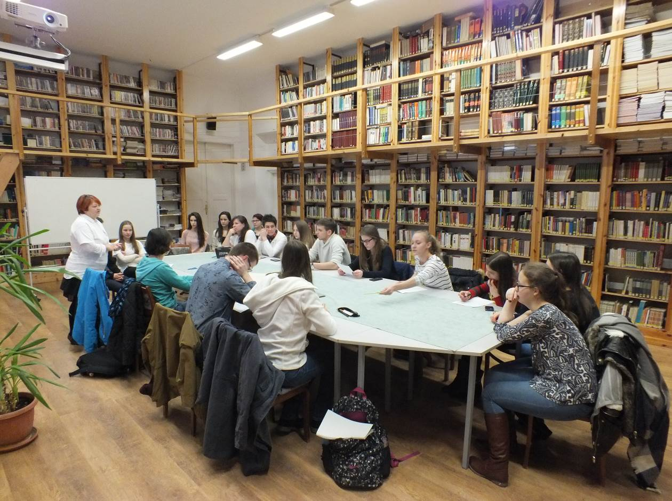
The Final
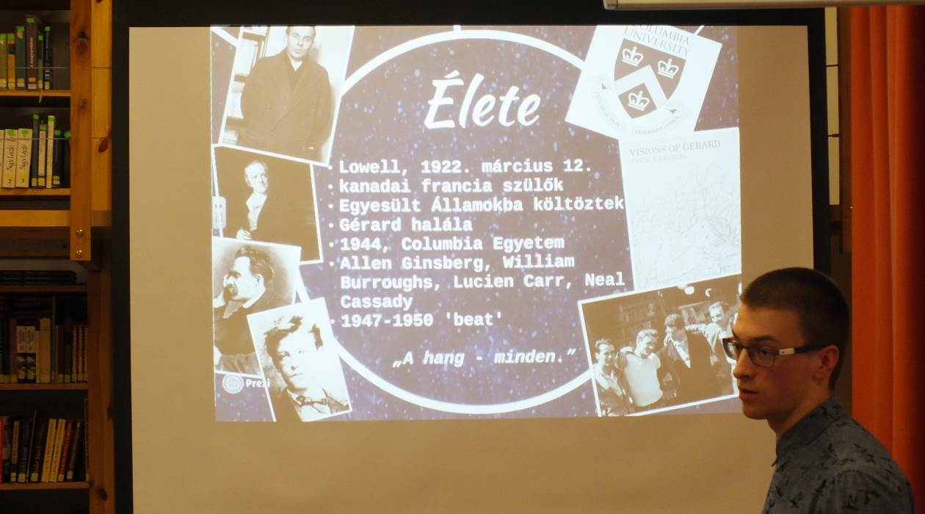
The Winner of the reading challenge – Áron Tihanyi

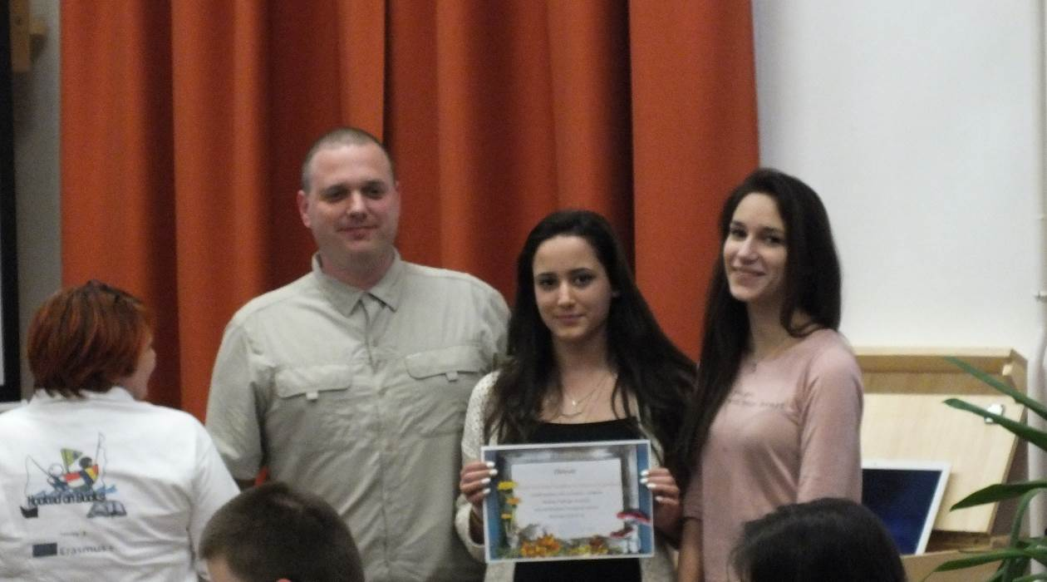
The winning class

