Best days in Finland
In the second half of April our Erasmus+ programme named Hooked on Books got to its final meeting in Finland, Juankoski. Being a transnational programme the language of work and communication was English. It was the tool that - besides their devotion to reading and literature - linked Hungarians from Transylvania and Hungary with their Finnish partners/friends.
So, the two key words: English and literature.
During the time of transnational meetings more families were involved in the programme in each country - they put up the guest students and teachers – so using English was not only natural but unavoidable, too. There was no other way to communicate with the host families, students and this way it gave us the real experience of the importance of learning foreign languages.
Of course it worked on the other way as well: in my host family there was a girl of seven, she did not speak English but for our sake she tried to learn some words and phrases to be able to talk to us. She was really interested in what we were talking about and was cute to try to communicate with us.
I think, an experience like this defines your life, and it must be one of the aims of a programme like ours.
Literature: I personally took a copy of The Tragedy of the Man translated into English, because I wanted to make Madách better- known. Unfortunately he is not known at all abroad.
Similarly, I am convinced that with our presentations on contemporary youth literature our teachers aimed us to find authors whose pieces of work are worth to translate into Hungarian/Finnish or at least a mediator language.
As for me, the meeting with the Finnish writers was the highlite of the programme. I t served the aim of our programme perfectly: we had a personal experience, met facet o face with two fantastic artists, who lead us to their world, to their creative life, this way introduced us part of Finnish literature at the same time. I simply hope, that this part of our programme was so impressive for the other participants as well.
The days in Finland provided a great opportunity to have a glance at their everyday life as well. Some of the opportunities were: the family day, visit to school, lessons together. Our impressions were surprising and brainstorming: special lessons of art and houshold jobs. It must help Finnish students become more practical, and develop skills needed in everyday life.
It might seem a slight difference but their special attitude to their environment is reflected in many things. E.g. inside the school they wear slippers, inside shoes; the canteen is self-service, which means they help themselves, so they only take as much as they want to eat not more; washing hands before eating – all these things prove their responsible care.
If I should mention the experience, it was the initiation ceremony, the beauty of the nature, lakes all around, the musems were fantastic. No boredom or hard times.
The family day, the school, those interesting lessons, changing shoes…No matter Juankoski is a very small place, many of the people live in the countryside just like us! Hanna Tihanyi
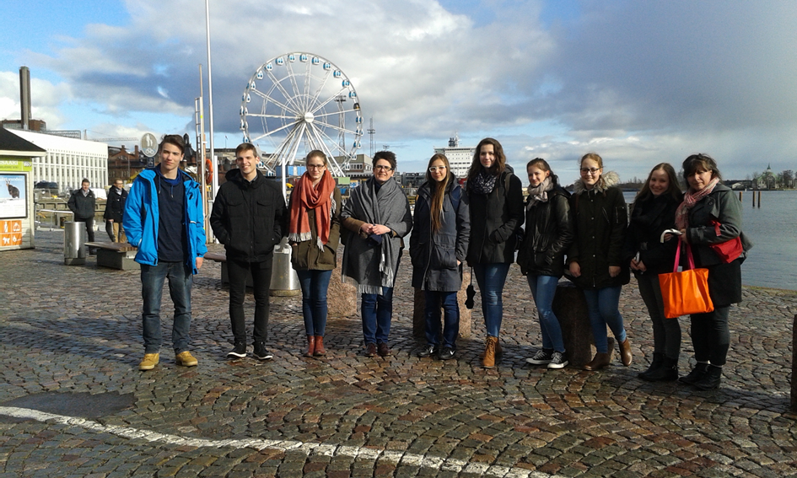
First moments in Helsinki
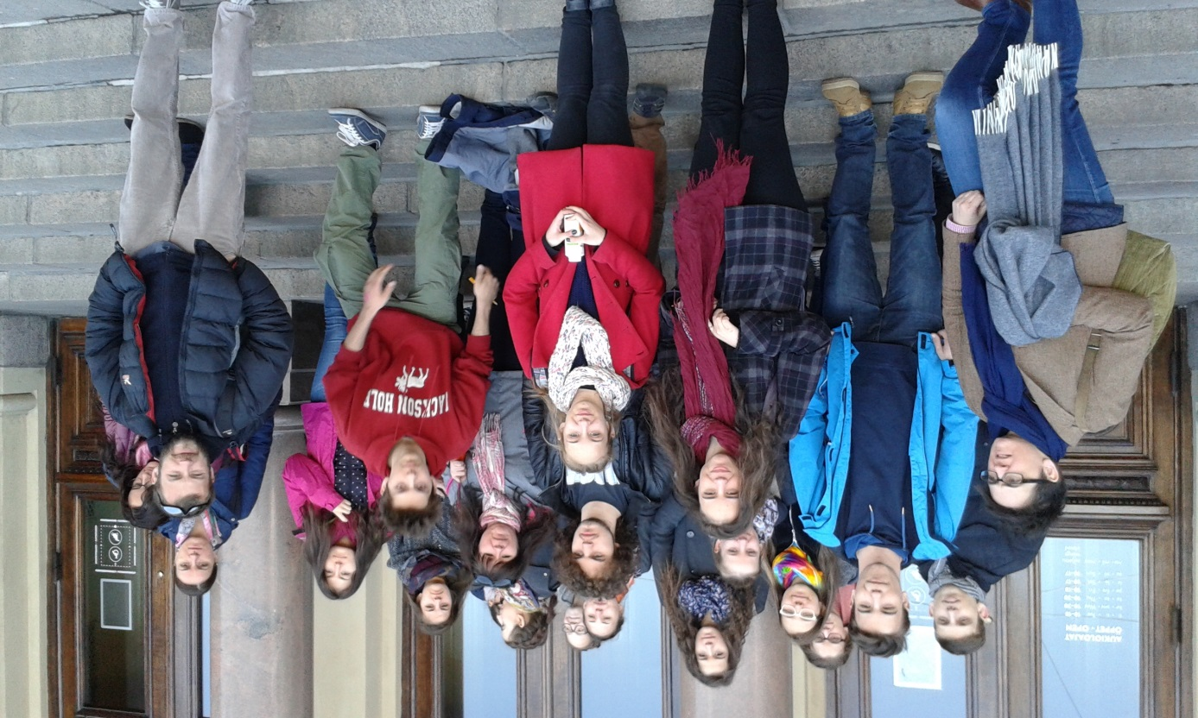
In front of the museum in Helsinki

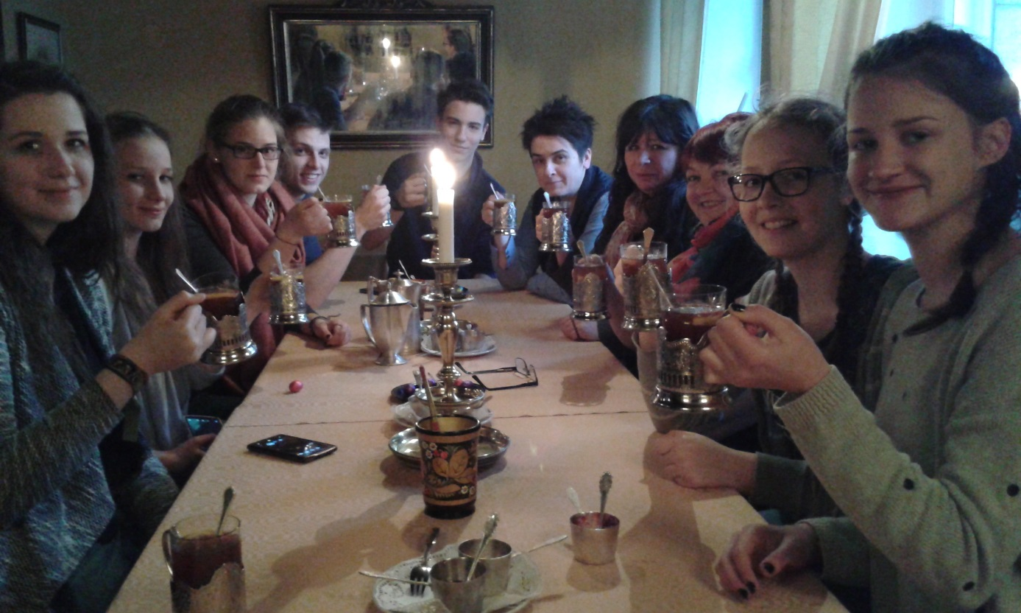
Trying traditional Russian tea

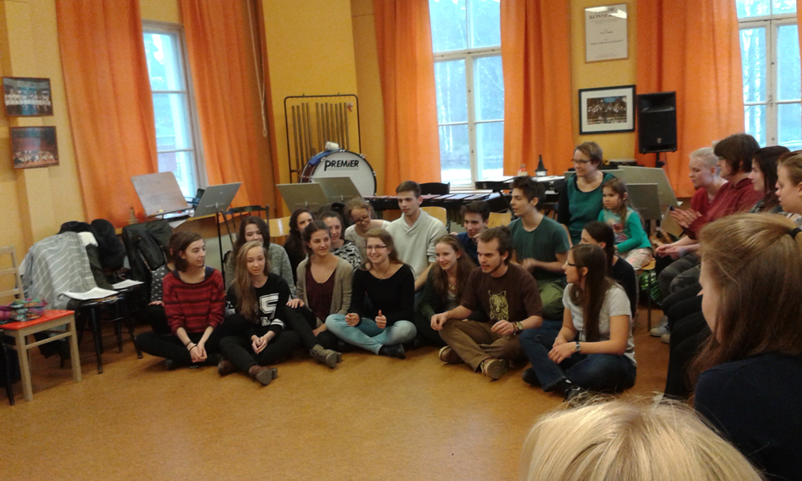
Performing together
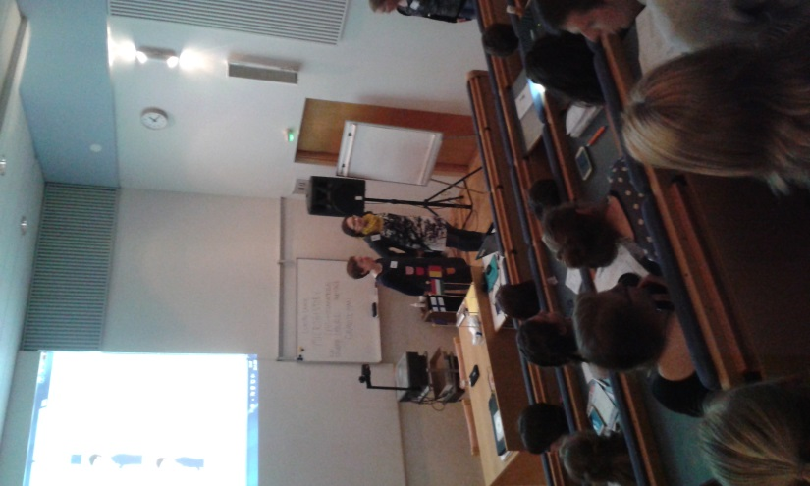
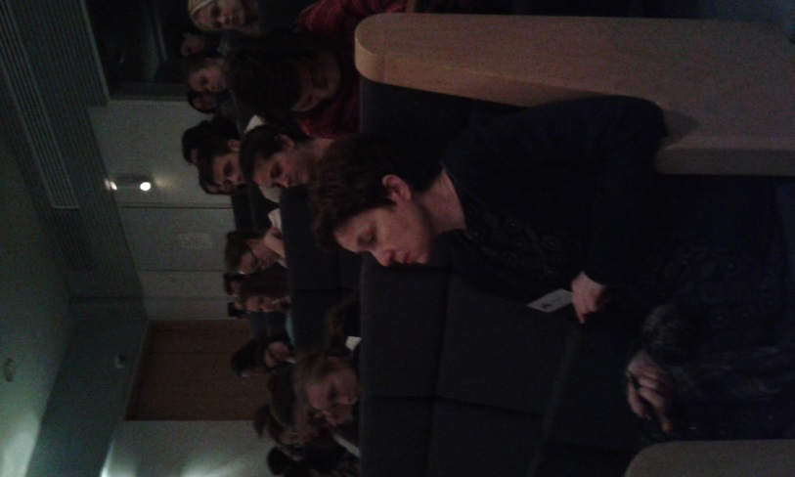The patrons of our Hooked on Books project, the most popular contemporary youth writers in Finland: Shirpa Kähkönen and Sari Peltoniemi

