Report on the reading habits of our students

Within the framework of Erasmus+, a survey was conducted among the students of the secondary grammar school as to how they relate to books.
This issue is of interest to the general public in Hungary, especially of those who are somehow or in some way related to this theme that is: teachers, librarians, publishing houses, and also in a wider sense, the intellectuals.
All in all everyone is concerned about the fact that irreperable harm is being done to the latest generations’ understanding and vision of the world. This is owed to the changes of social integration, which widens the gap between certain generations. What kind of impact does reading have on these things?
In reality there have been people who have been forecasting the arrival of the Gutenberg-galaxy for a long while. Similarly recent surveys just prove the fact that reading habits of people have been changing significantly. We must pay attention to warning signs.
The survey conducted in our community, actually, has tried to showcase these tendencies.
Should we just sit back?
In our school the main findings were as follows. Sixty-five% of the students read on a regular base (every day or several times a week - question 2). These readings are supposedly study-related ones besides the compulsory books. Though reading reader-friendly fiction is still as popular as ever (every other student prefers this) thus we may like to think that even on weekdays they tend to reach for such books (question 1). According to the survey one out of five admitted reading only in breaks off from school. If any conclusions may be drawn from these facts, they are, perhaps, as follows: we do have a different interpretation of reading. The connotation carried by ’READING’ is not necessarily related to coursebooks but rather is seen as an entertaining pastime activity.
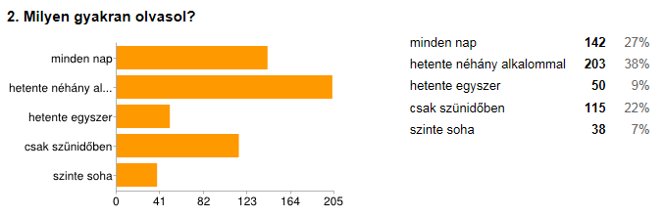
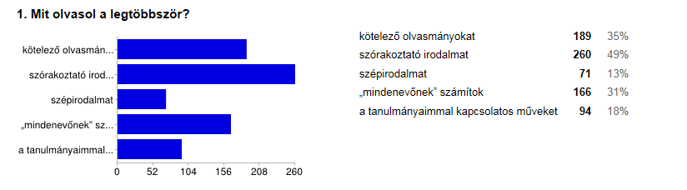
This final supposition is supported by the responses provided to question 3. The overwhelming majority, 66 % of students think of reading as a pastime activity to gain experience (this latest is not closely related to their school studies, though 35% have opted for that). Yet we can be pleased with their awareness of being able to develop their linguistic skills, also that of reducing cultural differences as 30% of them chose the answer stating that reading has a drastic influence on their vocabulary and imagination.
In contrast 44% of the students confessed that they have put down books unfinished (question 18).
Students tend to read more in foreign languages because reading as such is part of the national curriculum (question 19).
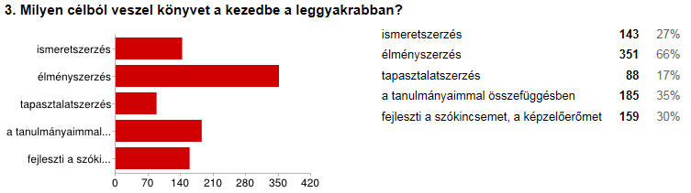
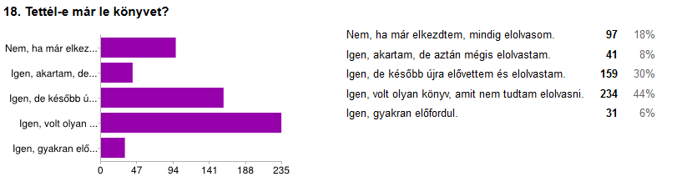
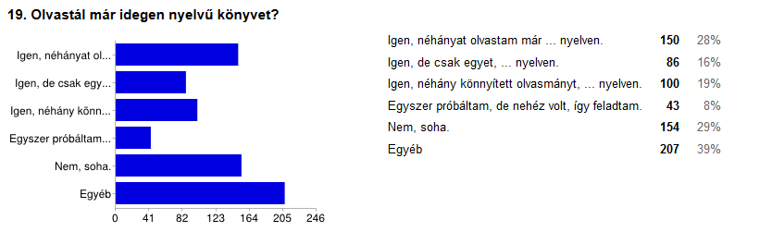
The majority of our students seem to act purposefully and thoughtfully, there is no doubt on their side what means to use to obtain knowledge in any subject (question 4). Course books are in a distinguished place (with 59%), yet the internet is the first on the list of priorities. In fact 79% of the respondees seek information on the World Wide Web proving the fact that they place complete trust in it. Thus we are given the challenge of teaching and directing them to reliable and trustworthy resources and how to avoid inaccuracies.
It is widely known though that sheer downloads are rather impractical and inefficient. However the World Wide Web also provides numerous theses, studies or on-line pages of great value, which can easily draw our attention and serves as our readings. Eighteen % of the respondees gain information from specialised publications, which proves the fact that they are library-attendees in search for either the latest or older materials or seeking in-depth insights.

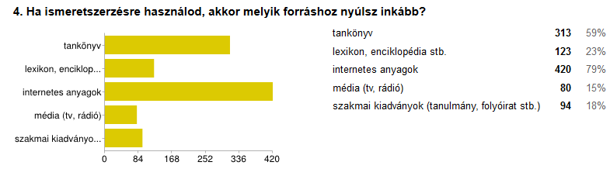
Perhaps the most important factor in the readers’ attitude is enjoyment (question 5). Popular fiction takes the first place (with 74%) followed by fiction taking second place. Although we should know how students have defined and understood the two genres. The clear definition of the latter, fiction is rather doubtful based on the responses given to question 1. Obviously students know that fiction is high-brow and artistic, though how much of their readings include those values is yet another dilemma. The wording ’I like it’ cannot really be called an exact measuring tool in literary canon. Comic books also appeal to an extensive fan club (24%), but to tell the truth this matter even among the students cannot be unanimous. Japanese and American comics are trendsetters among this world’s different subcultures. 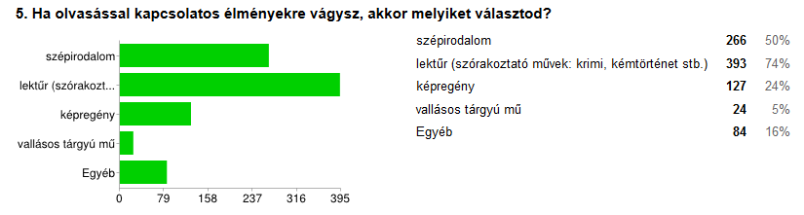
In light of the above mentioned factors respect for traditions seem to be solid in certain fields. Based on the replies given to questions 6-8, children start reading following in the positive footsteps of an outstanding person or family member. Education and the film industry also take a prominent role, though of a lower priority.

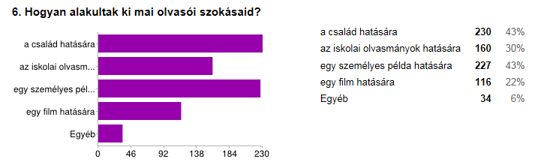

Printed versions of books are much more favourable (92% of the respondees) compared to any other available forms, yet in this regard the internet stands in second place. Apparently a wide scale of literary works is available in digital libraries in unabridged versions, which seems to be a priority with some publishing houses. The fact that many of the students purchase their books in bookshops or they are pleased to go to libraries proves that old habits die hard. The majority of our students are supposedly from family backgrounds as well as peer groups where they are expected to be well-informed in a way.
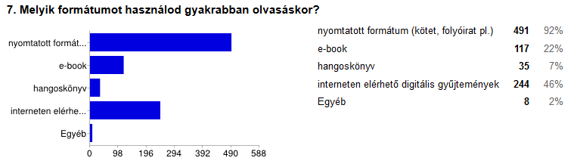
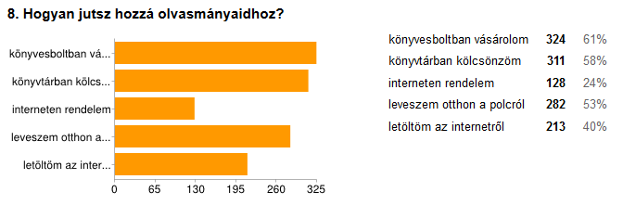
So what sort of readers are our students? In looking at the responses to questions 10-12, our students are strongly motivated by content and their emotions, they are keen on having discussions on given topics later on. Sixty-six % of them are open to having further discussions about their readings with someone else. Owing to literacy experts, these books which appear to be formidable are those which preoccupy our mind for days. If we speak about freshly read books, we can have deep inner knowledge about the world. Moreover, we ourselves are transformed.
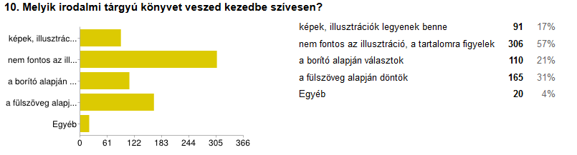
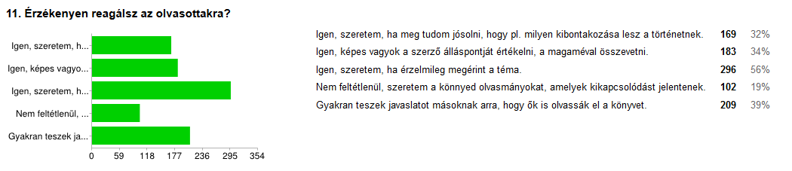
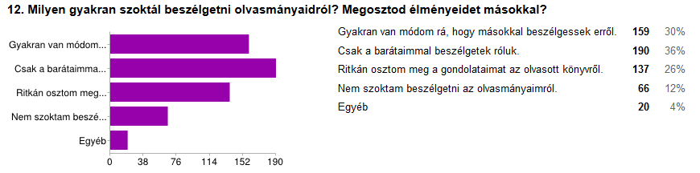
The next couple of questions (questions13-15) dealt with the role of literature at school. We are fortunate enough to find that more than half of the respondees consider literature itself of some value; furthermore many believe (38%) that it teaches about life, thus the importance of readings are not brought into doubt at all.
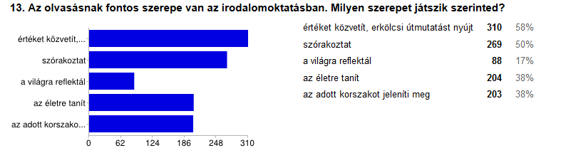

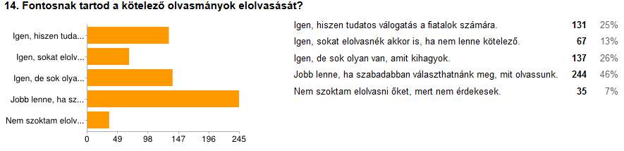
Though compulsory readings are a completely different matter as many of them are considered to be out-of-date, they are thought to be in need of some adjustment to our present day world. This former idea was supported by a huge number of students (46%). The debate about it is also of a professional nature, mostly to do with the curriculum, but interestingly enough our students rebel against the amount of their duties and not the school readings themselves.

Two other matters were made part of the questionnaire (questions 16-17). Contemprorary literature especially appeals to the 11th and 12th graders, especially if reading has been second nature to them. Only one out of five of those asked is fond of reading contemprorary literature, yet it is not known whether it refers to fiction or popular fiction. Once they are analysed separately, the figures would presumably be different.
In reality there are few occasions for personal encounters between readers and authors. This type of forum could be of some help to raise their interest in reading. Despite being in great demand (41% are eager to participate), only a few have had such an experience so far.
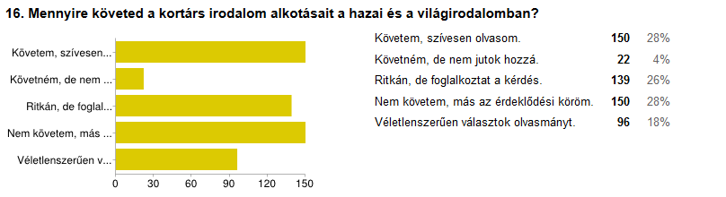

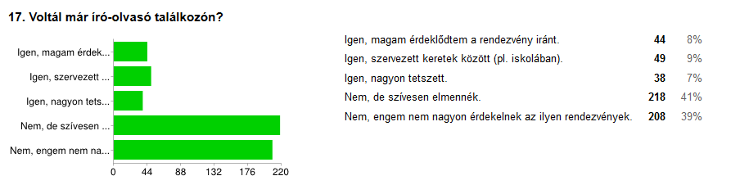
What is to be done?
On the one hand, there is no special reason to despair based on our findings. In our grammar school, reading seems to be a chic activity. We can easily come across some in the corridors holding a book in their hands, similarly, our school library is often visited by those eager to read.
On the other hand it is not all rosy as might be suggested. We have to work on language usage, dialects and extension of vocabulary. A completely new approach must be on the way in the world of films and high-tech gadgets.
Are humans the same as in the olden days? Or is it the world that has undergone dramatic changes? How is it all reflected in literature? Our students sure to expect us to convey values and a better understanding of the world.
First dare to ask, then reflect. It is certainly easier with the help of reading.

It would be advantageous to see its distribution in certain subjects, but sorrowfully it was not possible to conclude.
The students’ attention must be drawn to these collections as internet access can decrease inequalities.

